Photography ia-1

Name – mohd faaz khan

Section -5

Admission number- 22scse1010426

Photos:

Landcscape and images with background defocused:

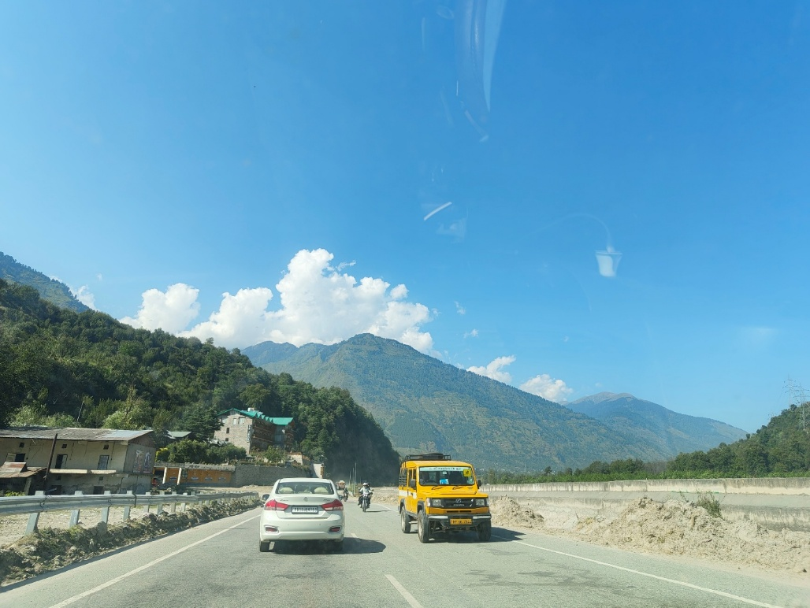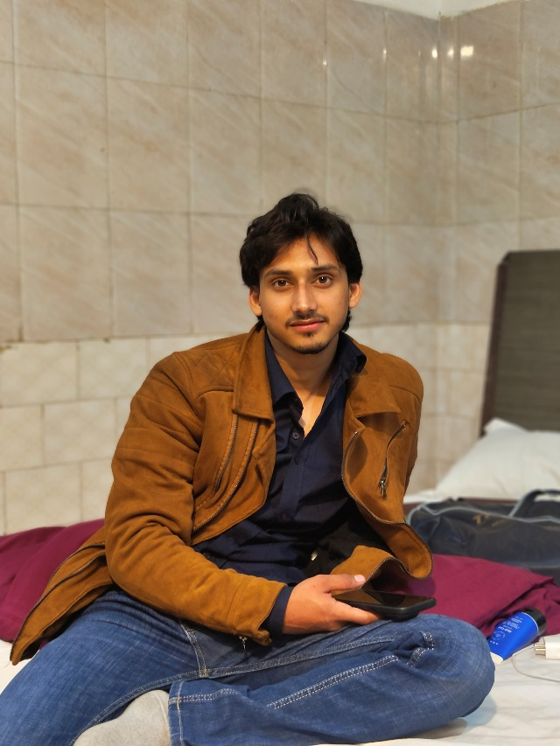

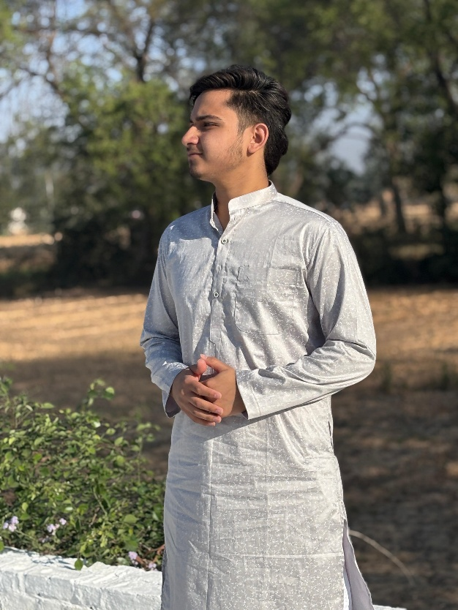

2- Different shutter speed photos

1st photo:

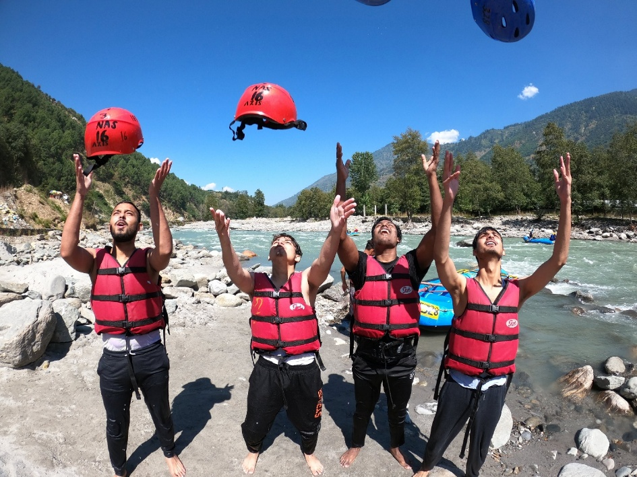

Shutter speed- 1/1000 sec

2nd photo:

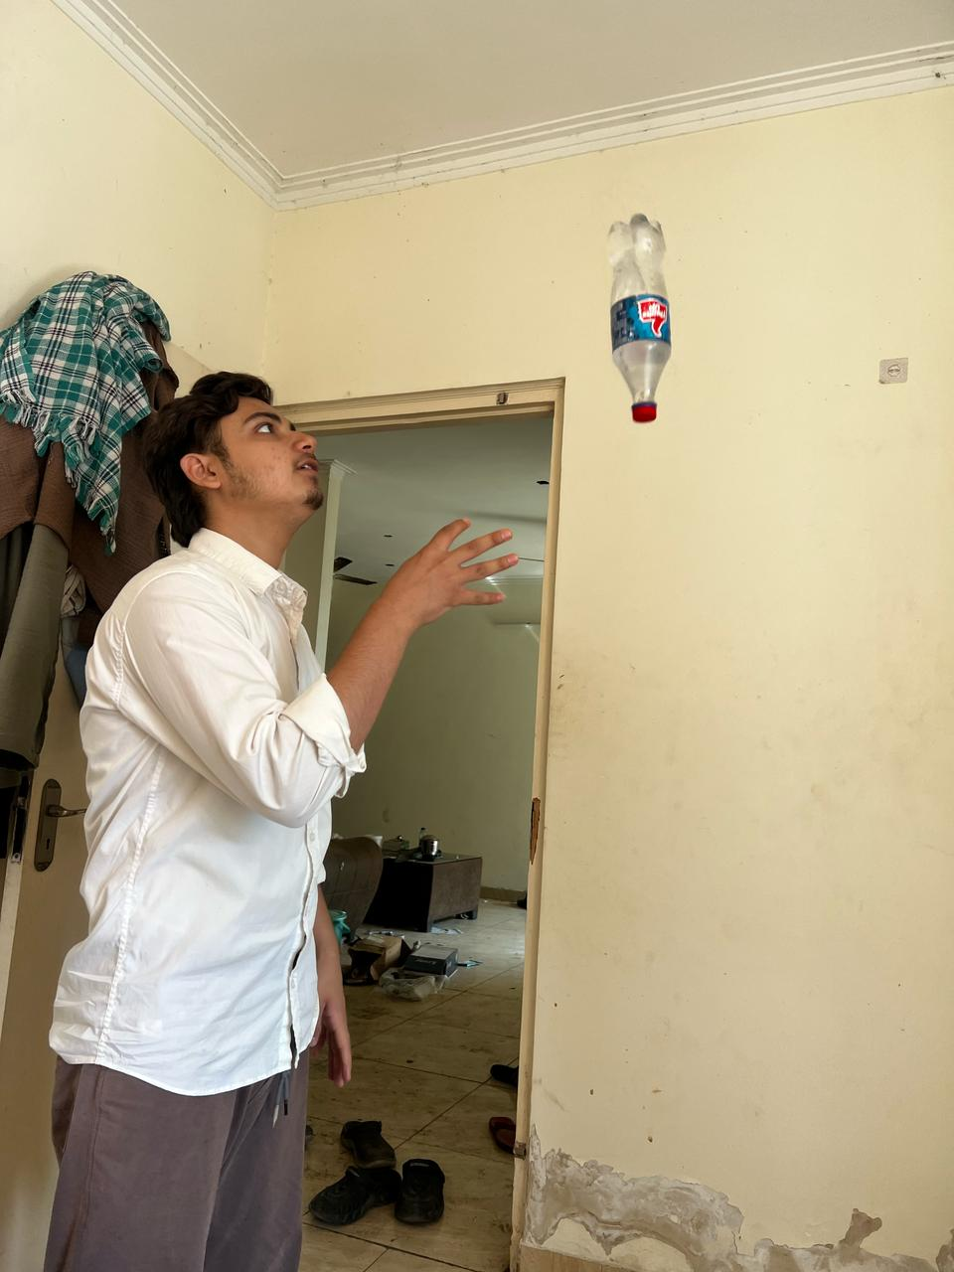

Shutter speed – 1/121 sec